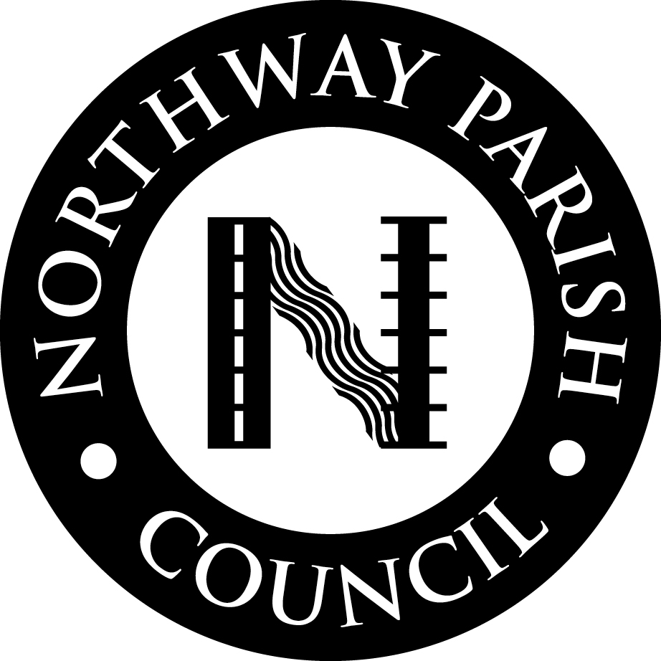
`

FULL COUNCIL
AGENDA

To: Cllr M Barnes Cllr J Beadle
Cllr C Blackmore Cllr P Godwin
Cllr P Mackenzie Cllr E MacTiernan
Cllr E Phennah Cllr J Roberts
Cllr G Shelton Cllr S Terry

c.c. County Cllr Vernon Smith
Will Luker, (Gloucestershire Live)

Date: 2nd May 2023

NOTICE OF MEETING

You are summoned to a meeting of the Council that will be held on WEDNESDAY, 10th May 2023, commencing at approximately 7.20 p.m directly following the Annual Meeting of Northway Parish Council, in the Ray Shill Room, Northway Community Hub, to include a period of public participation.

Members are reminded that the Council has a general duty to consider the following matters in the exercise of
its functions; Equal Opportunity (age, race, gender, sexual orientation, faith, marital status and any disability), Crime & Disorder (Section 17), Health & Safety and Human Rights

Consideration should be given to the impact of Council decisions on climate change and, in line with its policy, Members should do what they can to reduce the Councils carbon footprint, where reasonably possible.

Members are also reminded that photographing, recording, broadcasting or transmitting the proceedings of a meeting by any means is now permitted under the Openness of Local Government Bodies Regulations 2014.

The records of these meetings will be available online or by written request to the Clerk.

…………………………………….
Clerk of the Council

COUNCIL AGENDA

WEDNESDAY, 10 MAY 2023 at approx. 7.20 P.M.

1. Apologies for absence: To receive and accept / note apologies for absence.

2. Public Participation (10 minutes max) – As part of the Council’s ongoing community engagement members of the public are invited to contribute during this part of the meeting.

Members of the public can speak for up to three minutes on parish matters. These matters can only be debated by Members later in the meeting if there is an agenda item, if not it may be carried forward for a response at a later date or inclusion on a later agenda.

3. Declarations of Interest: Following adoption by the Council on 12th April 2023, of the Northway Parish Council Code of Conduct, Members are invited to declare any interest they may have in the business set on the Agenda to which the approved Code of Practice applies. Members are reminded that they should, at all times, observe the Code in carrying out their duties and that they signed such an undertaking in their Declaration of Acceptance of Office.

In addition, Members are reminded to declare any new Interests or notify the Monitoring Officer of any changes to their existing Register of Interests.

4. Minutes of Previous Council Meeting that took place on 12th April 2023: For approval and signature.

5. Matters Arising from Council Minutes/Clerks Report:

C/91/23 – Letters of thanks have been sent to contributors to the Warm Space.

6. Roads & Road Safety:

i. To discuss any issues of concern that require attention before the next Road Safety Committee Meeting or that are not the responsibility of the Stakeholder Manager and associated correspondence. To determine action.

ii. To receive any updates, if available, relating to installation of VAS posts and the ANPR camera application. To determine any necessary action.

7. County Councillor Report:

8. Planning Committee: To receive the Minutes of the Planning Committee Meeting held on 19th April 2023. (Copy circulated to Members)

9 General Purposes Committee: To receive the Minutes of the General Purposes Committee Meeting held on 19th April 2023. (Circulated to Members).

10. Finance Committee: To receive the Minutes of the Finance Committee Meeting that took place on 26th April 2023. (Copy circulated to Members).

11. Insurance Renewal: To receive recommendation from Finance Committee to approve the list of Assets (for insurance purposes) as well as the insurance renewal (to be tabled). To determine.

12 Asset Register: To receive recommendation from Finance Committee to approve the Asset Register for the financial year to 31st March 2023 to be attached to the Accounts. (to be tabled)

13. Borough Councillor’s Report: There will be no report this month due to recent Elections.

14. Council Accounts: To approve the schedule of bills paid and cheques for payment on 10th May 2023.

COUNCIL AGENDA

WEDNESDAY, 10th MAY 2023 at 7.00 P.M

15. Food Pantry:

i. To receive details of any further pledge offers from companies contacted.

ii. To receive update relating to building cost and its location. To approve.

iii. To consider any other relevant matters and determine including communications from Tewkesbury Borough Council relating to planning.

16. Events Working Party (Coronation of King Charles III): To receive the Notes from the Working Party that took place on 26th April 2023 (circulated to Members) and consider / approve any final requests from the Events Working Party.

17. Play Gloucestershire – A date has become available on 2nd June 2023 (May half term). The Clerk has accepted this date on behalf of Council. To ratify.

18. Standing Orders – To review Standing Order 5e Ordinary Council Meetings – The criteria for Chairman ‘A Councillor can only be elected as Chairman if they have served on the Council for a minimum of three years and attended a ‘Nuts & Bolts’ Training (or its equivalent) and have attained an attendance of at least 70% of all Council and Committee Meetings’

19. Crime & Disorder: To receive any information relating to crime and disorder (to discuss under confidential cover if necessary).

20. Correspondence for Action:

i. To receive a complaint from a resident regarding post received for Northway Youth Club. As no action has been taken to stop it she will try and get it forwarded to Northway Parish Council. To determine any action.

ii. To approve attendance at Code of Conduct Training at Tewkesbury Borough Council, dates to be tabled.

21. Tewkesbury Garden Town Meeting with Ashchurch Rural Parish and Northway Parish Sub-Group
Exclusion of the Public and Press under the Public Bodies (Admissions to Meetings Act) 1960 s.1 ss.2 Viz: -

That in view of the special / confidential nature of the business that is not yet in the public domain, it is advisable in the public interest that the public and press are temporarily excluded, and they are instructed to withdraw.

Exclusion Items – COUNCILLORS ONLY

22. Correspondence for Information:

i. Age UK – Updated version of the Tewkesbury Information documenter clubs and activities.

ii. National Association of Local Councils: Chief Executive’s Bulletin 14.04.23, 21.04.23

iii. Gloucestershire Association of Parish & Town Council: Presentation relating to Asset Transfers

iv. Local Giving – Newsletter including information relating to the Green Spaces Community Fund.

v. RPM Bike Trials Display Team – An offer to provide displays at Council events.

COUNCIL AGENDA

WEDNESDAY, 10th MAY 2023 at 7.00 P.M

23. Correspondence Available in the Clerk’s Office:

i. Tewkesbury Borough Council – Press Release ‘Council Awarded for Commitment to Carbon Reduction’.

24. Correspondence received after 4th April 2023

The next meeting of the Full Council will be Wednesday, 14th June 2023

